ACTIVITY REPORT
COMMUNITY ENGAGEMENT TO COMBAT FEMALE GENITAL MUTILATION

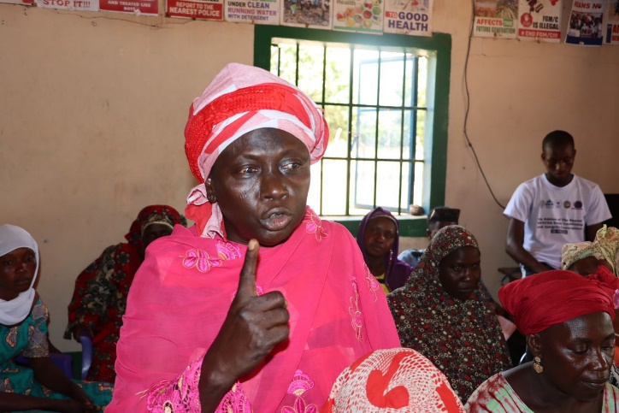
PROBLEM STATEMENT
Female Genital Mutilation (FGM) represents a severe violation of human rights and a significant barrier to the health and social welfare of girls and women in numerous parts of the world. In The Gambia, the practice of Female Genital Cutting or Mutilation (FGM/C) is deeply woven into the societal fabric, involving the complete or partial excision of the external genitalia of females. This custom has deep historical roots and has been sustained over many generations due to a variety of cultural, social, and even religious factors. It’s often considered an essential part of a girl’s journey into adulthood, signifying her transition from being a girl to becoming a woman and regarded as a key aspect of cultural heritage.
Presently, the hard-won ban on FGM faces a crucial challenge as there are movements within the National Assembly of The Gambia proposing to repeal the law. Advocates for the repeal argue that the law infringes on traditional practices and beliefs or cite religious obligations despite prominent religious leaders stating that FGM is not a religious requirement. The potential repeal is alarming as it would legitimize the practice again and undo years of progress. It was under this backdrop that the National Youth Parliament with support from Safe Hands for Girls implemented a community engagement to combat FGM. The aim of the activity was to raise public awareness and build solidarity amongst community members for the abandonment of FGM.

ACTIVITY REPORT
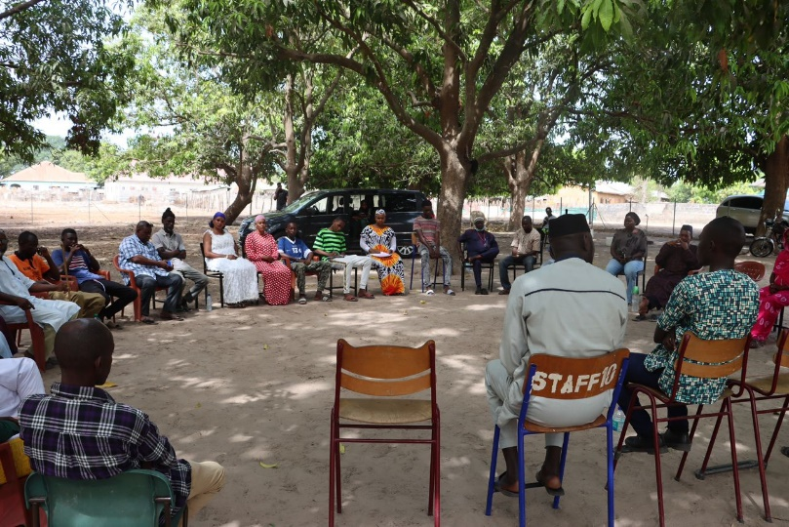
The National Youth Parliament (NYP), in collaboration with Safe Hands for Girls and the Africa Women Rights Advocates (AWRA), rolled out a second phase of the community engagement aimed at combating the issue of Female Genital Mutilation (FGM) in several constituencies; Foni Berefet, Foni Jarrol, Kombo South, Brikama North and Busumbala. The 5-day community engagement targeted over one hundred and fifty (150) participants including National Assembly Members (NAMs), community leaders, councillors, women groups, religious leaders, youth and persons living with disability.
Commencing in Foni, a district that has a high prevalence of FGM and resistant to the advocacy against FGM. Currently, the private member Bill in parliament that seeks to outlaw the ban on FGM is tabled by a National Assembly Member from Foni, he has got backing from his the communities and his fellow Members of Assembly within the surrounding district making advocacy efforts within the communities challenging.
The NYP using its persuasive authority and relationship with the National Assembly Members used community based approach to foster smooth dialogue with the community members.
During the engagement, the team focused on dialogue to hear the perspectives the participants on the issue. Mr. Mass Laye, a health expert presented comprehensive medical findings and facts regarding Female Genital Mutilation, highlighting its severe health risks and long-term psychological and physical consequences. Following this, participants were allowed comment on their experiences and share their thoughts about the ban on FGM. While a significant number wish the law to be repeal so the practice can be optional, many who have had experience or knowledge about the practice frown at the efforts to repeal and law and expressed their determination to protect future generations. A significant number of community members, including parents, emphatically stated that they would not allow their children to undergo FGM, citing the substantial evidence of its harmful effects. This sentiment was echoed by local leaders and Islamic scholars, who called for a collective effort and conversations regarding the practice.
MEDICAL PERSPECTIVE OF FEMALE GENITAL MUTILATION: MR. MASS LAYE
Mass Laye, an experienced health worker, initiated the presentations by shedding light on the background of FGM, exploring into various conducted studies and categorizing the types of FGM. According to him, there are 4 recognized types of FGM practiced globally, however the types practiced in the Gambia are [Type 1 known as clitoridectomy involves partial or total removal of the clitoris; Type 2, known as excision, involving the cutting of the clitoris, and the labia; Type 3 known infibulation/sealing, which involves sewing/binding the genitalia together] Amongst these types, he stated that research has shown type 1 and type 2 to be the most common in The Gambia.
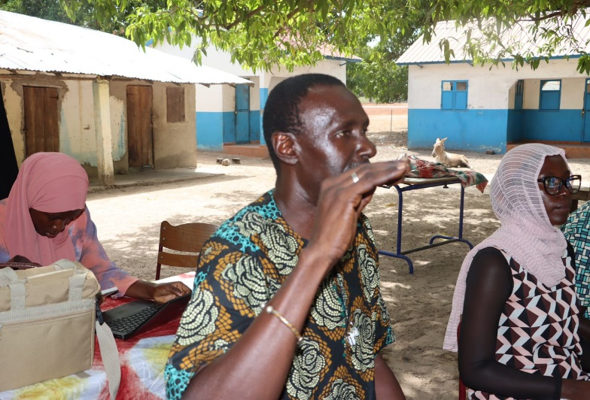
He further shared his wealth of experience in the health sector, highlighting the short-term and long-term complications associated with the practice. Mass Laye emphasized on severe cases where complications arise from extreme blood loss during the process; such scenarios often offer minimal chances for saving young girls' lives. This can sometimes lead to the death of the child if proper care is not taken. He added that the several conducted studies on FGM, showed that higher rates of delivery complications occur in women who have undergone at least one type of FGM.
He outlined an array of medical issues like excessive bleeding, urine retention, fistula development and infections. Advocacy efforts were discussed where he highlighted an approach used in the past years focusing on 'Initiation without Cutting' to curb the spread of this harmful practice. He emphasized on the implications of FGM Type 3 on mental health and psychological wellbeing of survivors.
Mr. Mass Laye pointed out other medical concerns such as issues arising during menstruation, keloid formation post-procedure, and sexual dysfunctions including sexophobia. He brought attention to how the deep-rooted culture of silence contributes to perpetuating misinformation about FGM. Remarkably, women’s discussions about sexual matters or genitalia are shrouded in discretion.
Furthermore, he explained long term complications especially during childbirth were described as largely stemming from labia minora/majora removal - structures that not only serve as a protective barrier for the vagina but also provide necessary elasticity during childbirth.
Notably, Mass Laye underscored how FGM's ramifications go beyond affecting women alone; babies too are at risk with potential outcomes such as brain damage being a result of this practice.
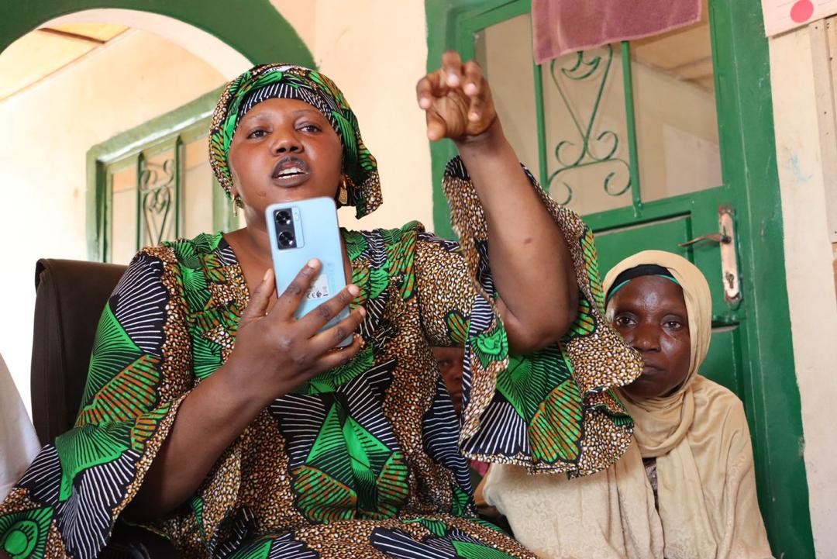
He further outlined that FGM/C is a deeply-rooted and a very sensitive topic to discuss. However it is crucial is educate communities. He iterated that the culture of silence in the Gambia contributes to perpetuating misinformation about FGM/C. Remarkably, women’s discussions about sexual matters or their genitalia are shrouded in discretion. This has left many communities and individuals in denial of the risk involved in this practiced.
Mr. Laye highlighted many real life scenarios during his presentation, elaborating that the severity of the complications depend of how severe or the type of FGM a person has undergone. He elaborated while this practice is sometimes done to stop girls from being promiscuous or prevent teenage pregnancy, the number of young girls who are sexually active before marriage is alarming despite the signicant number of girls that have undergone the practice.
In his final notes, he reiterated the need for open dialogue. Stating that name calling and insults will never solve the issue of FGM, while noting the importance of community participation in dispelling misconceptions and misinformation about FGM as crucial in effectively countering the practice.

COMMENTS AND QUESTIONS
Day 1: FONI BEREFET
- In religion, there is no shyness, especially on issues that serve a good cause. We should openly discuss these issues so we can all learn something new. We are not disputing the facts told by the health expert. These are knowledge that you have because of your work, and it is important to share with others. FGM is considered a sunnah in Islam and was advised by the Prophet. Therefore, those practicing the act should be well-trained on how to do it properly. Imam Babaye Jarju
- This discussion has been going on for a long time now. I witnessed an incident where a woman got divorced because she developed keloids from FGM. Also, during one of our campaigns with communities, we encountered many cases of fistula the majority of which developed during delivery. This is why it is important for us to discuss, listen, and enlighten each other on the issue. Fatou Gassama
- I believe that there are complications associated with FGM, but convincing people who currently practice it will be very difficult. I believe what we should do now is train doctors and professionals to perform it to minimize these complications. Lamin Ceesay
- FGM as a sunnah is not bad; the only issue is the more extreme forms, which I believe shouldn’t be done. However, connecting the practice to delivery complications is misleading. There is no connection between the clitoris and the birth canal where the baby passes through, and it is very normal for women to experience some minor complications during delivery because they are giving birth to a whole human being. FGM is a fight against religion, and if they succeed in banning the practice, then the next thing we will see is gay and lesbian marriage in this country. Let's leave the practice as a choice and allow people to do what they want. Hon. Amie Colley, NAM for Foni Brefet
- Emphasized that the most important aspect of the sensitization for her is the health perspective. She stressed that while they may want to circumcise their children, it cannot be done if they are not in good health. However, she also explained that FGM is rooted in religion and culture, and therefore they will continue to practice it. She added that if anyone seeks their votes or support, they should allow them to practice FGM. Fatou Fatty
- As a man, I may not feel or experience the pain that these women go through, but I have sisters, and someday I will have a wife who may experience the same pain. That's why I am not in support of FGM, and I believe the rights of the majority should be respected. Ebrima Jarju

Day 2: FONI JARROL
- Laws exist in every country, and it's important for people to adhere to them. He emphasized that they will remain obedient as far as the law banning FGM is concerned and will do whatever possible to bring the practice to an end. The Alkalo of Sintet, Dembo Badjie
- FGM is a long-standing traditional practice. However, since it has been confirmed to be harmful to women and girls based on medical evidence, it is best to engage in dialogues and determine the best approach to address the issue. Alhagie Samba Bah, a community leader and peace negotiator.
- FGM is a long practiced tradition, since there are implications attached to it, I believe it's ideal to stop it. We ca not continue to practice a culture that will harm our daughters in the futures. Ali Jallow, a traditional leader
- FGM should be left as a personal choice. I believes that those who want to practice it should be allowed to do so, while those who do not want to participate should also have the freedom to refrain. Alhagie Dodou Ceesay Imam of Foni Jarol
- The impact of FGM on women is significant, affecting childbirth and many other aspects of their lives. However, we know that when Islam is involved, eradicating such practices becomes difficult. Nonetheless, if we are to speak the truth, FGM has causes more harm than good. Binta Colley
- FGM should remain banned due to the severe consequences it has on women and girls. I have decided that my daughter will never go through such pain in the name of tradition. Awa Sowe

- I believe FGM should be banned because it affects women significantly, and many of them lose a lot of blood during the process. Madi Baldeh, a student.

- FGM is not a traditional practice; rather, it is Islamic. However, the way it is done now creates a problem. The real issue is infibulation, which is not Islamic. Mustapha Kanteh

- Our society believes that girls and women who have undergone FGM are less sexually active and have a lower chance of getting pregnant than those who haven’t undergone FGM. This is why so many people practice it. Kumba Bah

Day 3: KOMBO SOUTH - Gunjur

- The initial ban on FGM has caused ongoing debates. There should be a dialogue and conversation to understand what the problem is and where it is coming from. Islamic scholars and leaders should conduct thorough research on this issue. While the practice is Sunnah, how many of us actually adhere to it as advised or even advised the circumcisers on how it is supposed to be done? Abdoulie K. Touray, Imam of Gunjur

- FGM should be a topic for national dialogue. The government cannot simply ban the practice without consultation because it's a longstanding issue. Mariama Janbang

- Since I was young, we've been told that girls who haven't undergone FGM aren't considered clean and pure compared to those who have. Is this belief in line with Islamic teachings? Abi Khan Bojang

- Answer: This belief is not supported by Islamic teachings, and there is no Hadith that states such. FGM is a cultural practice adopted by some, but it's important to note that the Prophet (SAW) did not force anyone to undergo it. Outass Abdoulie

- We should increase consultation and dialogue on FGM to understand people's perceptions and develop strategic approaches. Without this understanding, simply banning it will prove to be difficult. Momodou Charr Gibba. Councillor of Gunjur Ward

- FGM is a Sunnah of the Prophet (SAW).The problem now lies in how it is practiced, which complicates the issue. Sulayman Touray, representative for Kartong VDC

- I can recount an incident where a woman was divorced because she had undergone infibulation, a fact neither she nor her husband were aware of it at the time. Due to the inability to consummate their marriage, the husband divorced her. Isatou Jammeh

- You mentioned the use of tobacco powder by women for sexual enhancement during your discussion. How does this affect them medically? Binta Bah

- Such dialogues and sensitization are very important. She also suggested that these discussions should target older generations, as they are the ones perpetuating these practices without valid reasons. Sirreh Janneh, Gunjur VDC member

- Women are very sensitive and should be respected. Men should make every effort to respect and support women, especially regarding issues that clearly affect their well-being. Nfamara Jallow

Day 4: BRIKAMA NORTH
- All the effects and health consequences of FGM you discussed are really important for us to know as youths. But I want to know whether there has been any research showing the positive side of FGM? Sulayman Manneh
- Answer: As per medical ethics, anything removed from a woman’s body without medical purpose is harmful, that is why medically FGM is never encouraged. Mass Laye responded
- I have never been engaged in this kind of conversation since the issue of FGM started. I believe if we have been engaged and sensitized about these issues we can also have the conversation with our fellow young people. Ousman Drammeh
- I have heard that women or girls who are not mutilated or circumcised usually have bad scents from their private parts. Is this true? Binta Saidy
- Answer: That is a misconception, smelling and body odor mostly have to do with the individual’s personal hygiene. Mass Laye

Day 5: BUSUMBALA
- I have learnt something new, something that I had never heard before. I went through FGM when I was young; the pain and suffering are still vivid in my memory. I am a victim of it, and I can say this is a serious and harmful practice. I am now married and have children, but this discussion has been really helpful, and I have learned a lot. While giving birth, I encountered complications. Sometimes, the doctors had to widen me because of how tight I was. This is an issue about women, and I think men should really stay away from it because we are the ones going through the pain, and we know how it feels. FGM is not something we want. Otrance Bora

- I believe that the problem with FGM is that those practicing it aren’t doing it the right way as advised by the Prophet (SAW). Musa Krubally

- In all this I think children should be allowed to decide whether they want to undergo FGM or not. Sulayman Bangura

- A child cannot give consent. So what’s best is to let them BE until they reach the adult age to decide what to do with their body. Hon. Kaddy Bah, NYP member for Busumbala Constituency

- It is importanct to have such conversations to hear the community's concerns and issues.
- Creating an environment that is free and conducive for them to speak is crucial. Aside that, let us engage our families and communities when we go back home to share the lessons learned here but please in a very respectful and responsible way. Kaddy Bah.

- Such gatherings are important, we can dialogue, and raise awareness about the health issues attached to the practice. I believe this issue is clear. We all know and have seen how it has affected women who have undergone the practice. Yankuba Jammeh

- I have done my own consultations on this issue. In some areas, people understand the consequences, but in other areas, it was really tough. During my consultations, I was able to convince ‘ngansimbaa’ who vowed never to perform the practice again. Hon. Mbemba Touray, Ward Councillor of Lamin

- This issue is about women, and we hear their cries. I want the NAMs to ensure the voices of women are heard and protected. Sulayman Bojang

- I have younger sisters, and I have told my mum that if she takes them to perform FGM, I will report her. FGM is harmful and should be stopped. Fatou Keita

CONCLUSION
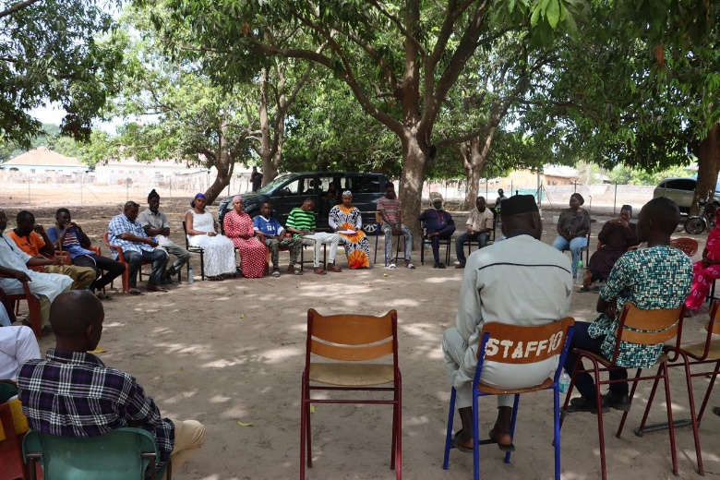
The five-day community engagement indicates a promising step forward in the fight against Female Genital Mutilation (FGM) in The Gambia. During the engagement, it is understood that the prevalence of FGM is higher in communities where practicing tribes like Jola and Mandinka are residing. These communities are more resistant to the advocacy effort. However, the knowledge gap between participants who have had previous engagement on the subject are more committed to end the practice than those who have not. This showed more education is needed on these areas. While some participants remained unmoved and in denial, a significant number believe FGM when done in a careless manner can cause damage to the individual.
With the concerted efforts, vital discussions on the medical, religious, and human rights aspects of FGM can go a long way in creating positive FGM in the community. It is through these educative discussions and shared experiences that communities can foster an environment where all members are informed and empowered to take a stand against FGM. The insights gained from this initiative are not just an end but a beginning it is a call to action for continued advocacy, policy-making, education, and community-driven change.

ACTIVITY PICTURES
